

EGFR (T854A)
Catalog Number: CR-M26481
Gene Symbol: EGFR/HER1/ERBB1
Description: Anti-EGFR (T854A) Mouse Monoclonal Antibody

Background: EGFR is a receptor tyrosine
kinase binding ligands ofthe EGF family and activating several signaling cascades to convert extracellular cues into appropriate cellular
responses. It activates at least 4 major
downstream signaling cascades including the RAS-RAF-MEK-ERK, PI3 kinase-AKT,
PLCgamma-PKC and STATs modules. Defects in EGFR are associated with lung cancer
(LNCR).
Immunogen: A synthetic peptide from the internal region of EGFR which includes the mutation ofT854A, human origin.
Tested applications: ELISA, WB, IF, IHC Recommended dilutions:
ELISA: 1:1000-1:5000
WB: 1:1000-1:5000
IHC: 1:50-1:200
Concentration: 1 mg/ml
Host: Mouse
Clonality: Monoclonal
Purity: Purified from ascites
Format: Liquid Storage buffer:
Preservative: no
Constituents: PBS (without Mg2+ and Ca2+), pH 7.4, 150 mM NaCl, 50% glycerol
Species Reactivity: recognizes EGFR (T854A), but not wild type EGFR from vertebrates.
Storage Conditions: Store at -20°C. Avoid freeze / thaw cycles.

Western blot:
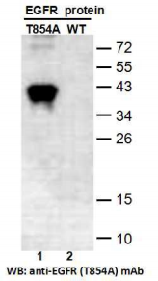
Western blot analysis of recombinant EGFR (T854A) and wildtype proteins. Purified
His-tagged EGFR (T854A) protein (lane 1) and corresponding wild type protein (amino acids
702-987, lane 2) were blotted with anti-EGFR (T854A) mouse monoclonal antibody (Cat.
#26481).

For research use only. Not for diagnostic or therapeutic applications.

Immunofluorescence:

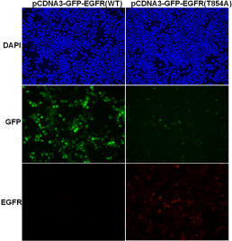
Immunofluorescence of cells expressing EGFR proteins with anti-EGFR (T854A) antibody.
HEK293T cells were transfected with
pCDNA3-GFP-EGFR (WT) plasmid (left column) or pCDNA3-GFP-EGFR (T854A) plasmid (right column), then fixed and stained with anti- EGFR
(T854A) monoclonal antibody (Cat. #26481).

